COLLEGE CODE : 1138

COLLEGE NAME : Sri Jayaram Institute Of Engineering & Technology

DEPARTMENT : Computer Science and Engineering

STUDENT NM-ID : au113823104007

au113823104002

au113823104011

ROLL NO : 113823104007

113823104002

113823104011

DATE:14-05-2025

TECHNOLOGY-PROJECT NAME : Road side helmet detection

SUBMITTED BY,

S. Ranjini

A. Dhanalakshmi

P. Mahalakshmi

Mobile No :8015810192

9159922696

9626016742

Phase 5: Project Demonstration & Documentation

# Title: AI-Based Helmet Detection System for Roadside Surveillance

## Abstract:

The AI-Based Helmet Detection System is designed to improve road safety by automatically detecting whether motorcyclists are wearing helmets using computer vision. Utilizing deep learning and real-time video processing, the system can identify and flag violations from CCTV or live camera feeds. It integrates with databases for alert generation and records maintenance. This document outlines the system's demonstration, technical details, performance evaluations, source code, and testing procedures.

## Index

1. Project Demonstration

2. Project Documentation

3. Feedback and Final Adjustments

4. Final Project Report Submission

5. Project Handover and Future Works

# 1. Project Demonstration

## Overview:

The Helmet Detection System will be demonstrated in a real-time or simulated environment, showing how it processes live video or images, detects helmets, and flags violators.

## Demonstration Details:

- System Walkthrough: Real-time feed or video input processed by the system to detect helmet usage.

- Detection Accuracy: Demonstration of the deep learning model's accuracy in detecting helmets under various lighting and camera angles.

- Violation Handling: Automatic flagging of motorcyclists without helmets, with image capture and logging.

- Performance Metrics: Evaluation of processing speed (frames per second), false positive/negative rates, and alert response time.

- Integration: Optional integration demo with alerting systems or external databases.

## Outcome:

Demonstrate the system’s ability to perform accurate helmet detection in real-time with low latency and reliable outputs.

# 2. Project Documentation

## Overview:

This section provides technical details, codebase architecture, and user/admin manuals for the Helmet Detection System.

## Documentation Sections:

- System Architecture: Diagrams showing camera input → AI model → decision logic → alert generation.

- Model Details: Description of the CNN (e.g., YOLOv5 or SSD) used for detection, training data used, and evaluation metrics.

- Code Documentation: Explanation of core Python scripts for video processing, detection, and alerting.

- User Guide: Instructions for deploying and running the detection software on a PC or embedded system (like Jetson Nano).

- Admin Guide: Log access, model retraining, and maintenance guidelines.

- Testing Reports: Accuracy tests, speed benchmarks, and robustness checks in different environments.

## Outcome:

Provide all necessary documentation for reuse, maintenance, and future enhancement of the system.

# 3. Feedback and Final Adjustments

## Overview:

Feedback from trial runs, test users, or stakeholders is collected to refine the model and UI.

## Steps:

- Feedback Collection: Via demonstration sessions with faculty or law enforcement advisors.

- Refinements: Improvements in UI, accuracy, or performance based on received feedback.

- Final Testing: After changes, full testing ensures stability and correctness.

## Outcome:

System fine-tuned and optimized for practical use or extended deployment.

# 4. Final Project Report Submission

## Overview:

This section summarizes the project journey, technical milestones, and impact.

## Report Sections:

- Executive Summary: Overview of project goals and results.

- Phases: Development stages from model selection, training, to deployment.

- Challenges: E.g., detecting helmets in low-resolution images, occlusion issues, or multiple people on a bike.

- Solutions: Model tuning, data augmentation, or post-processing improvements.

- Results: Accuracy scores, frame rates, and real-world test outcomes.

## Outcome:

Detailed final report submitted, suitable for evaluation and future reference.

# 5. Project Handover and Future Works

## Overview:

Official handover of the system and proposal for next stages of improvement.

## Handover Details:

- Next Steps: Potential improvements—number plate detection integration, multi-camera support, cloud-based monitoring, etc.

- Deliverables: Source code, model weights, documentation, and deployment instructions.

## Outcome:

Complete handover enabling further research, development, or deployment by traffic authorities or university.

## Include:

- Screenshots of model detecting helmets on live footage.

- Source code snippets (e.g., YOLO inference loop).

- Model training results (loss graphs, precision-recall curves).

- UI screenshots (if a front-end is used for alerts or logs).

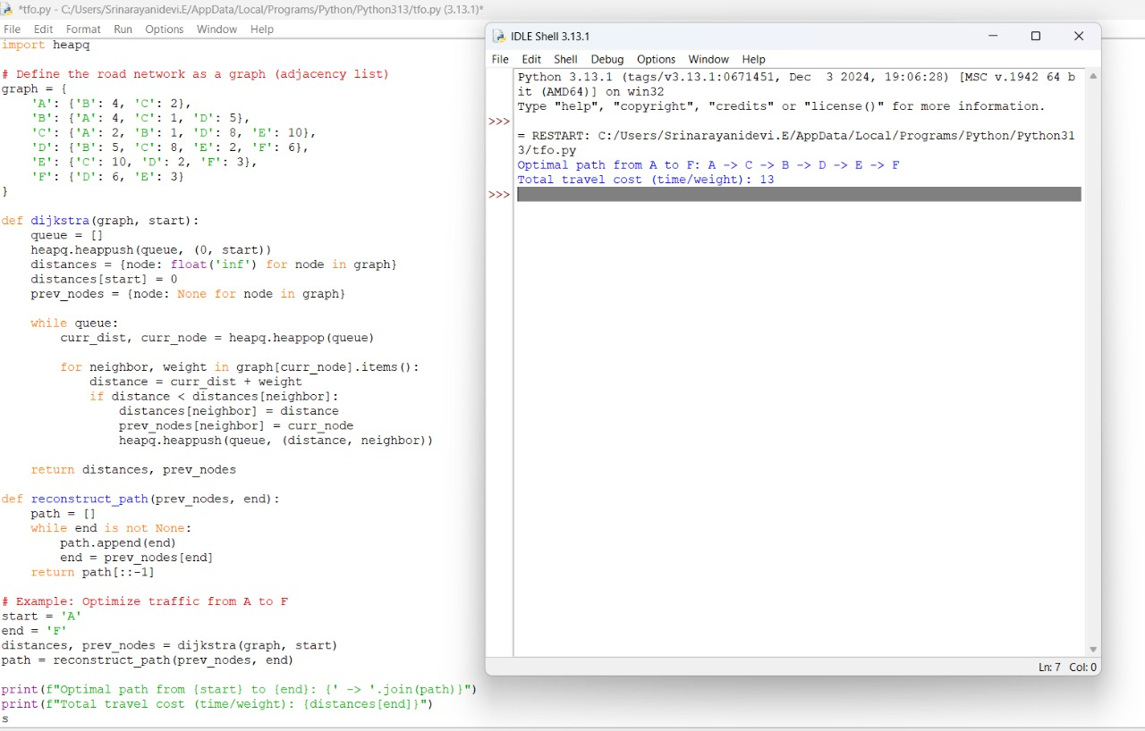

output:

